Report

Laboratory Work 8 - 9

Dmitry Ladutsko

August 16 - 17, 2022

# 

# 1. Prerequisites Task Information

## 1.1. Passwords Index

|  |  |  |
| --- | --- | --- |
| Password Group | Login Name | Password |
| Operation System | root | “rootadmin” |
|  | oracle | “oracleadmin” |
|  |  |  |
| Oracle System | sys | “sysadmin” |
|  | system | “sysadmin” |
|  |  |  |
| Oracle Users | All DB users | “%PWD%” |
|  |  |  |
|  |  |  |

## 1.2. Folder Paths Index

|  |  |  |
| --- | --- | --- |
| Path Group | Path Description | Path |
| Operation System | Oracle RDBMS – BIN | /oracle/app/oracle |
|  | Oracle Inventory | /oracle/app/oraInventory |
|  | Oracle Database Storage | /oracle/oradata |
|  | Oracle Install Directory | /oracle/install |
| Oracle | ORACLE_BASE | /oracle/app/oracle |
|  | ORACLE_HOME | $ORACLE_BASE/product/11.2 |
|  |  |  |
| FTP | ftp Incoming Folder | **/ftp/incoming** |
|  |  |  |
|  |  |  |

# 2. ETL Extraction - BASIC

## 2.1. Task 01: Extraction Description

**The Main Task** is to create chapter in the Solution Concept Document that will explain extraction properties and strategy for your Business Task, according Exit Task for Module 6 – Introduction to DWH.

**Task Results:**

Create required objects:

* Prepare Document with new Chapter.

***Note.*** From my point of view the offline extraction can be assessed as followed: as data is not directly taken from the source, it already has an existing structure, namely it can be tablespaces and logs or in another case the structure may be a result of the extraction method.

Another type of extraction, namely, full extraction may be described as complete pulling of data directly from the source. This may be beneficial in a sense that there is no need to track the source system as the extraction process reflects all the available data in the system.

***Note.*** New Chapter “Extraction Description” will be added to Business task solution concept

# 3. ETL Transportation – Example of Loading FCT_*

**Task 02 is common for LabWork 08, 09.**

## Task 03: Prepare Table of Facts to DW Layer

**The Main Task** is to create required objects on DW layers and realize load process for Facts

**Required points:**

* Create new package for Load FCT_* to DW Layer

**Task Results:**

Create required objects:

* Put objects script to Git.
* Prepare Document with Screenshot of Data

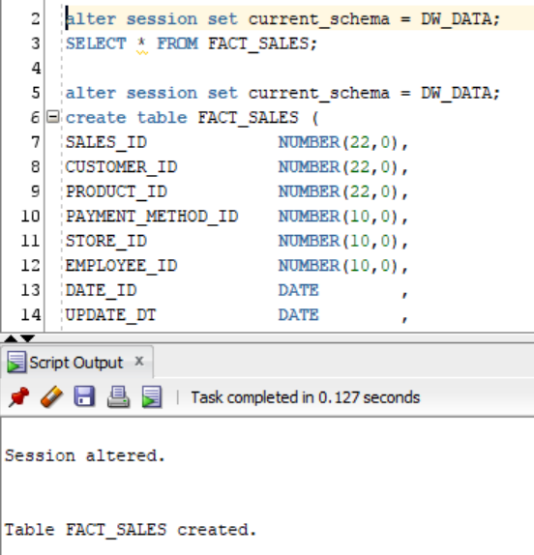

***Note.*** Fact table created

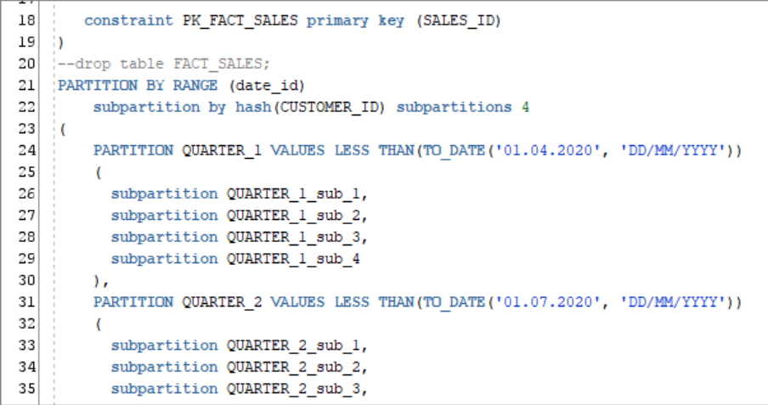

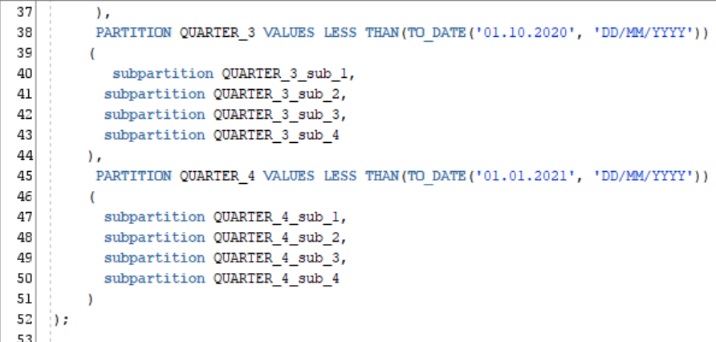

***Note.*** It’s Primary key and partitions (with sub – partitions)

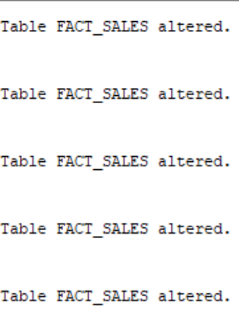

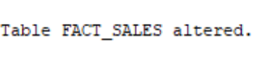

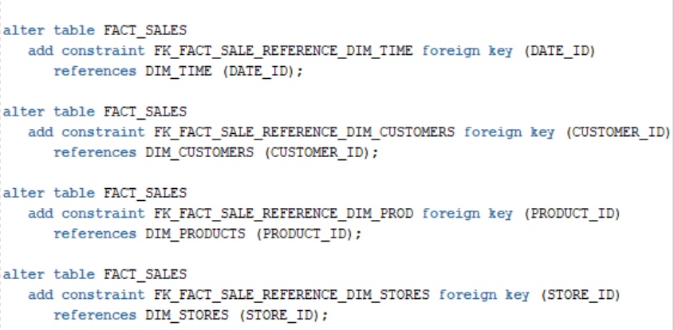

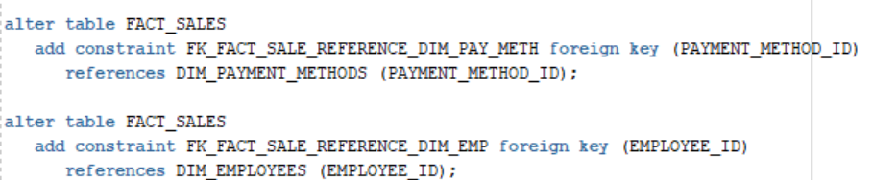

***Note.*** Foreign key constraints. FACT_SALES TABLE CREATED BEFORE, IN MODULE 1, but now a little bit modified. DDL script added to Laboratory Work 8 – 9 folder and exit task folder.

**Laboratory Work Summary**

**At this Laboratory Work** we practiced more how to create fact table ….